KOTH_Quarry
Development Log

October 24, 2024

Map Layout. 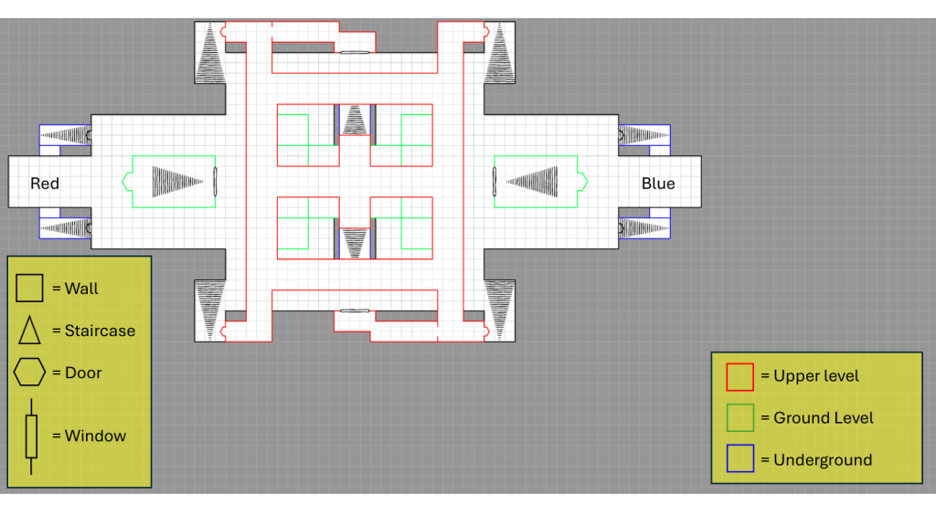
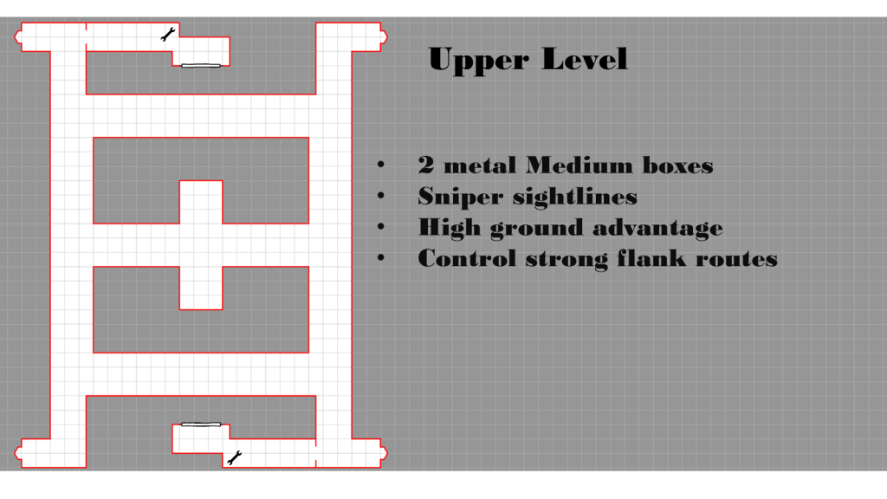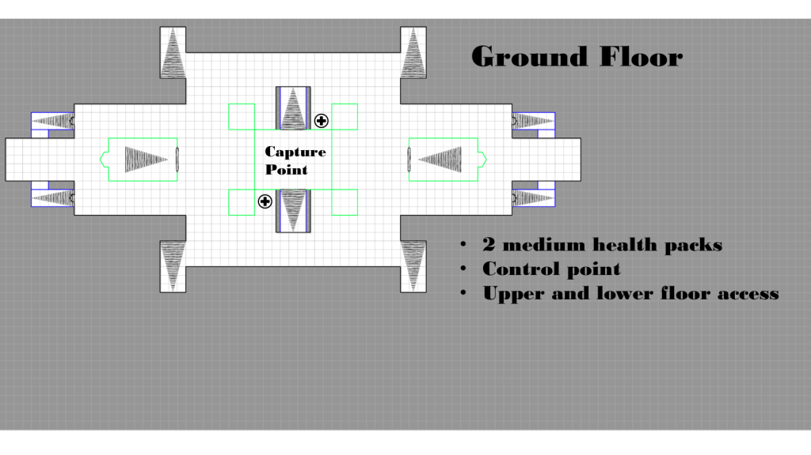

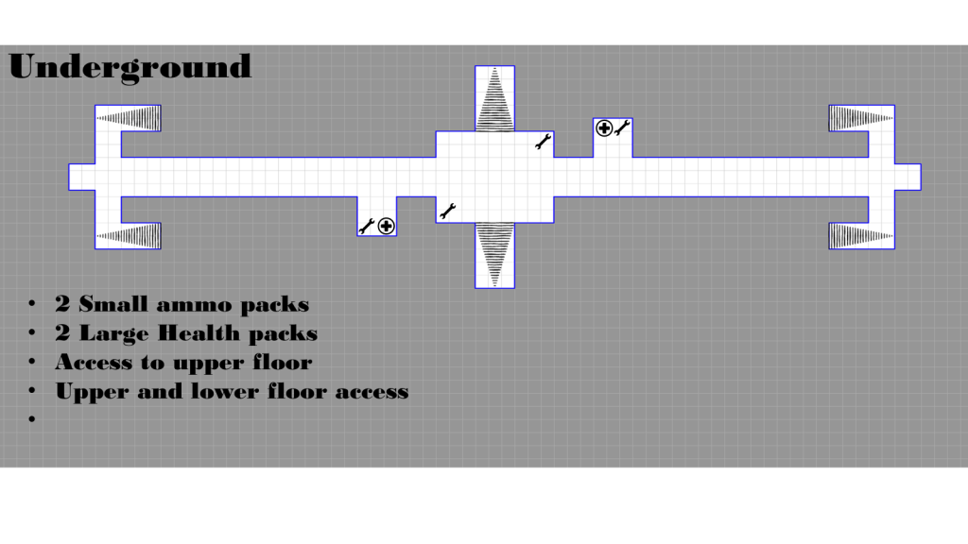
November 5, 2024

Initial block out.
Top-Down view of the map
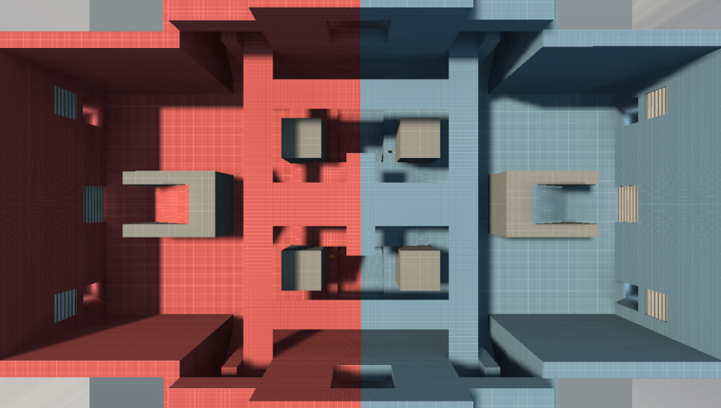

Overlooking the Capture Point.
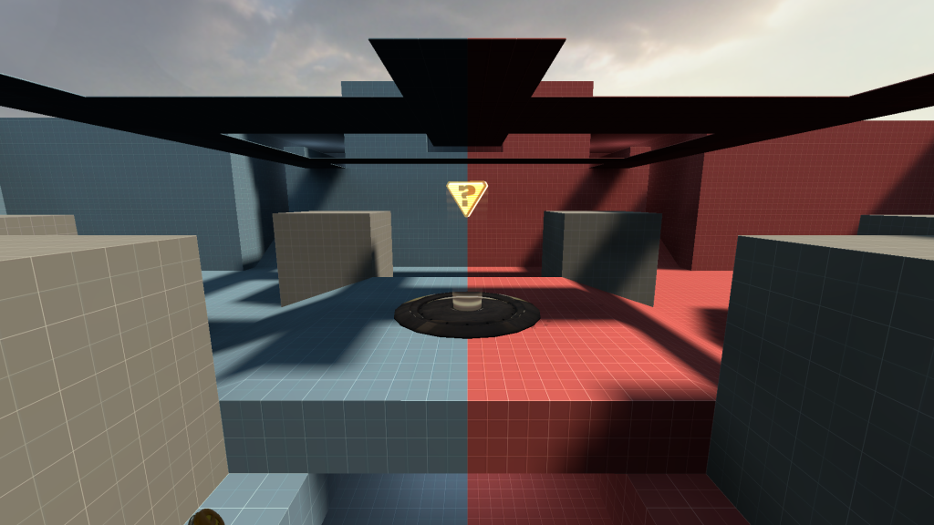

Underground Cubby.
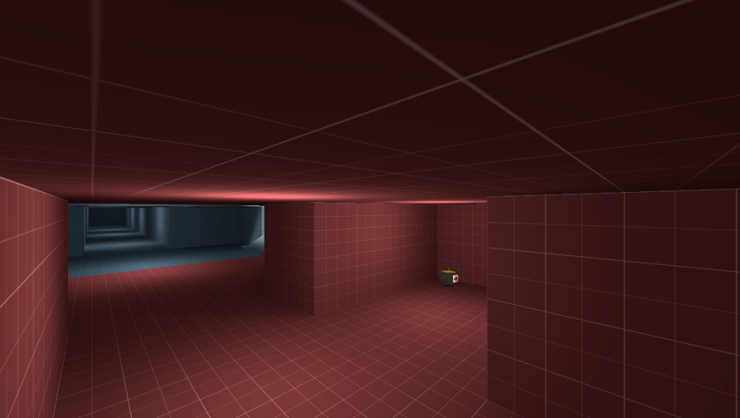

Underneath the capture point.
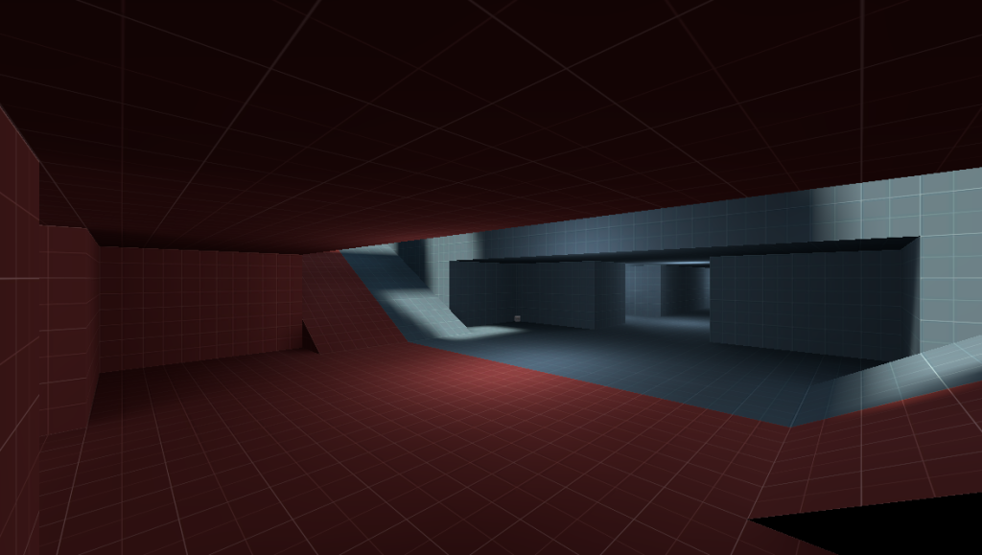

Upper floor lookout.
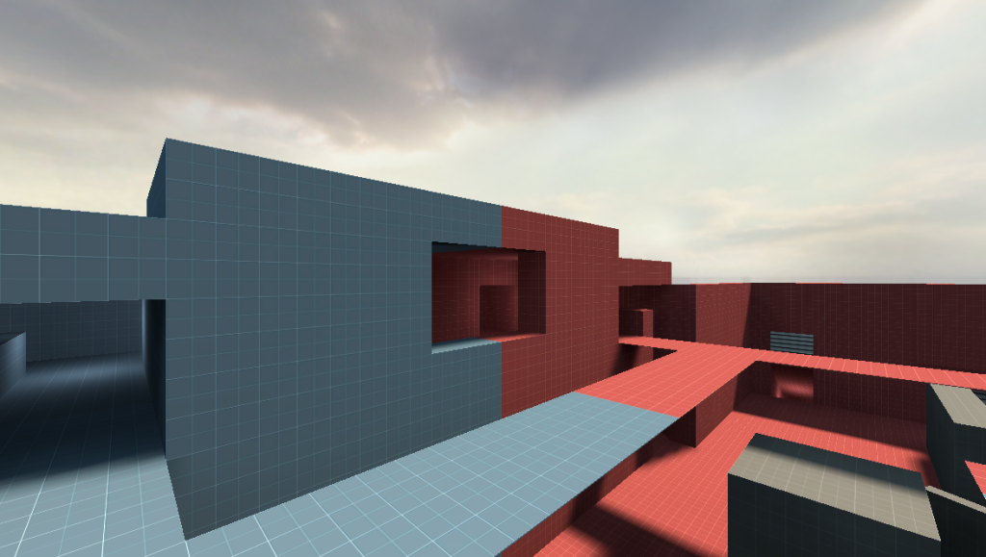

Here are a few screenshots of initial bot playtesting showing the map in action.

A sniper utilising the high ground to get a view of the point.
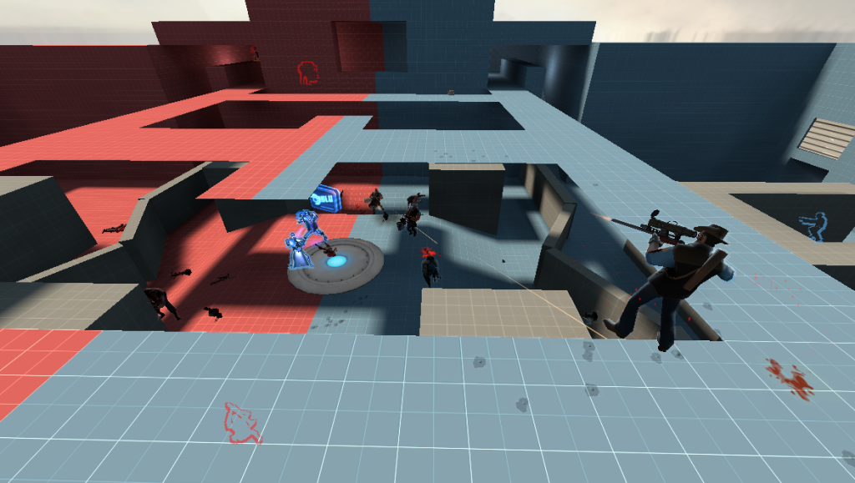

A Soldier using the high ground to get a kill on a pyro on the point.
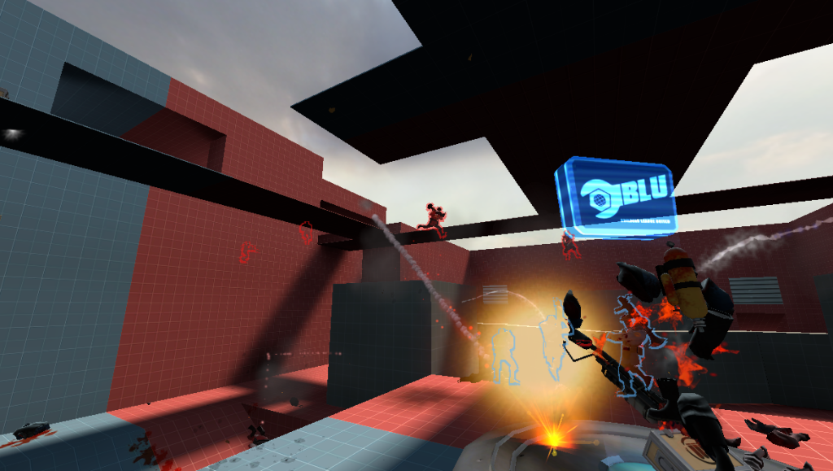
Here are my comments after the first bot playtesting
“Overall, I’m happy with the first block out. Having done a few sessions of bot testing it has confirmed that the level is playable and captures the chaos that I wanted to achieve. Some bots used the space beneath the point to heal up and escape the chaos from above and some even used the high ground to gain an advantage and a sightline over the point. The bots aren’t perfect though and tended to just mindlessly run onto the point and kill each other, this however led to an interesting playstyle where the point would change hands every 30 to 40 seconds leading to overtime brawls a lot of the time, as the team that had just lost the fight for the point would come back with full health giving them an advantage.
This is the first iteration of the map that I’m going to test in class.”

Thinking about possible problems and feedback I might get would probably be:
- The pacing of the map (how long you live before dying)
- The size of the map (being to small)
- Not needing to use the lower / upper floor.

November 7, 2024
Map Feedback and changes from first player test session.
I got some really good feedback from people that were able to playtest my map, this feedback has been very helpful at diagnosing some issues with the map that effect the player experience as well as the overall feel of the map.

When I made the questionnaire, I wanted to focus on points that i felt needed changes, these being the different levels and how players would traverse the map since it is so small.
My first question was What class did you play the most during playtesting?:
From the responses I got, Scout and Demo man were the most popular tying at 3 plays each, this didn’t surprise me as on small maps these classes excel at area control and denial.

My second question was Where on the map did you go the least?:
The overriding response was the top area; this was interesting to me as I thought that more people would have used its vertical advantages more.

The next question was a follow up, Why did you go to this area the least?:
The responses that I got on this question were really helpful and informative. They told me that the high ground was hard to get to and didn’t give much of an advantage, other responses said that it wasn’t the best area of the sniper and that due to it being so open it was easy to be killed and that their wasn’t a lot of fighting on the high ground as most of it was happening on the point and underground meaning there wasn’t really any incentive to go up there. From this feedback I will look to give the high ground more importance and power.

The next question was about pacing Did the pacing of the map affect how you played?:
The responses to this question were interesting, some people felt like the pacing didn’t effect the overall gameplay feel and how they played whereas others did feel like it effecting how they played. There were a lot of responses about the capture point and how it felt too hard to capture and when you were actually on the point you were very exposed and would die easily since there wasn’t any cover to protect you when you were on the point. After reading these responses I went into hammer to have a look and realised I never changed the capture radius when I imported the point into my map, this would have been the reason why it felt so impossible to capture the point, I will still need to address the cover issue later but for now this should be a somewhat fix for making sure the capture point feels better to take.
Before
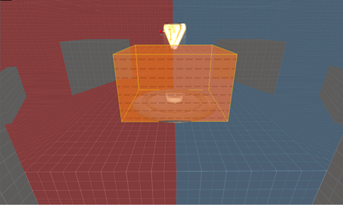
After
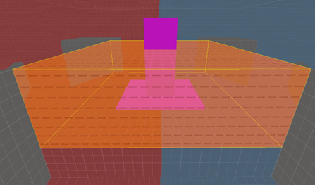
My last two question were aimed at getting a general sense of how the players felt about the map and what they would do to improve the map.
I asked them What 2 changes would you make the map?:
I was able to get a wide range of responses on this question, one person commented that when playing sniper they would have to move to close to the door in order for it to open, heavy was too strong on the upper level, More cover was needed to get to the point as their team was being killed before they could even make it out of the spawn and they would change the underground to be less direct. All of this feedback was really helping me understand what players themselves wanted and felt like could be improved.

And finally my final question was What are 2 things you liked about the map?:
The feedback on this question were really nice to read as they consisted of all the key points I wanted to address when making this map, they really liked the different levels and the amount of pickups around the map, they liked the fast paced and chaotic gameplay that the map delivers, they liked the layout of the level as it felt fun, fast paced and very different to other maps they had played, they enjoyed the great sightlines and thought that the map was decently balanced for all the classes.
“Overall this feedback has been extremely helpful, so far I have started making adjustments based on feedback, the main change I have made so far adding a V shaped wall in front of the point on both sides, this during bot testing changed the flow of the map by separating the main clumps of enemies as they had to attack the point from either the right or left side instead of just running in head first, it gave medics the chance to stay alive longer and charge Ubers as well as teams to flank around to the side of the point and gain easier access to the underground from the point. The shape itself when through several iterations as I wanted to find the right balance between an obstacle that you had to pass around comparted to a wall that chocked the flow of the map.”
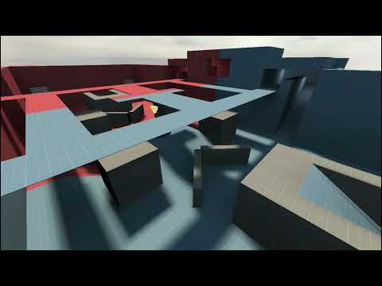

November 16, 2024
Map Feedback and changes.
The feedback from the last round of playtesting highlighted a few key issues; many players felt the map was two small and cramped, so cramped that it impacted the gameplay flow and the player experience. This feedback came from many people talking about the limited options when it came to getting onto the point and the fact that there was nowhere else to fight other than the point leading to the capture point being incredibly difficult to capture and hold down for long periods of time.
To address these concerns, I focused on opening the sides of the map, this adjustment was aimed to provide more lateral movement and more options on where to fight other than the point itself.
I also decided to open out the middle of the upper level above the capture point to address other issues that emerged during playtesting. Many people said that the upper level was too oppressive if a heavy got up there and that there was no way to properly counter people just spamming explosives onto the point since the angle and positions that the high ground gave were way too difficult to counter.
By opening the centre, it introduces more sightlines and increases the amount of exposure a player faces when using the upper level, this forces players who use the upper level to be more strategic instead of being able to just spam rockets and other weapons from above.

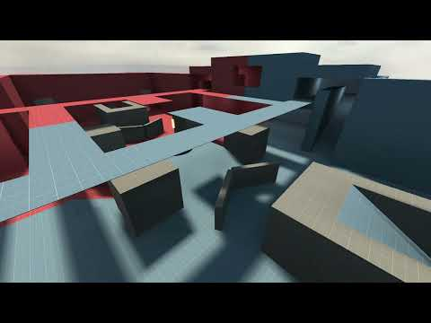
This is the map iteration that I had players play on for my user playtesting session.
I kept my questions the same as last time since I felt that they covered the areas that I wanted to know about.
I did add one question about if the map felt small, I added this because the large change I made was to alter how the map played by giving more space to move around in. I wanted to gage whether the changes I had made were successful on the overall impact of the map.

Questions and feedback:
What class did you play the most during playtesting?:
I was happy to see that there was much more class diversity this time round, here is what was played during the first session:
First Session
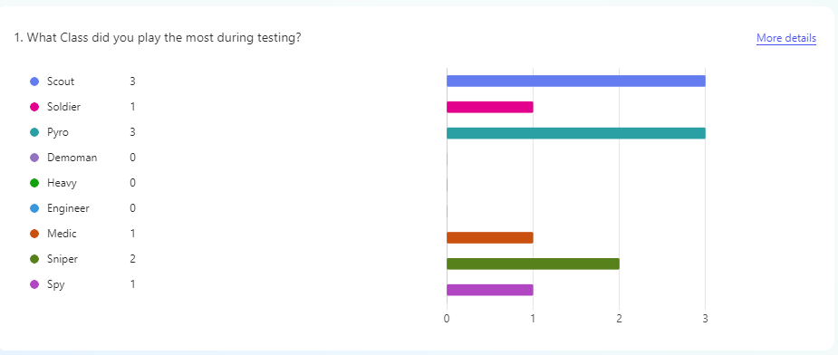Second Session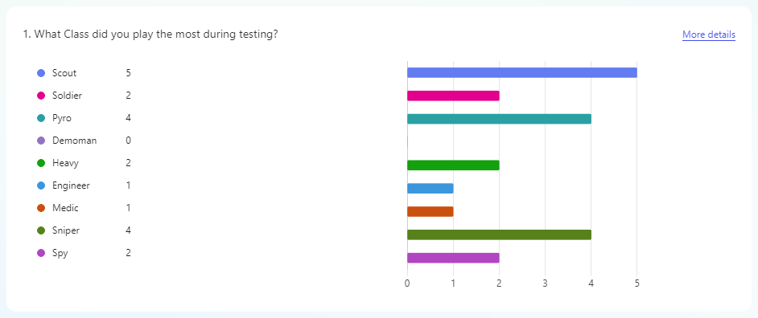
Having a wider range of classes played meant that more strategies and variants of play could be explored and found. This leads to healthier gameplay and the less likelihood for stomps and one-sided games, meaning I will get better result and feedback from players.

Where on the map did you go the least?:
The overwhelmingly response to the question this time was the Underground area, this surprised me since when designing the map, I specifically made the underground easily accessible from the capture point, so to hear that people went there the least was surprising.
An Internal reason behind this is due to the changes I made to the upper level; people realized the changes and utilised the upper level more than last time since it was more balanced and gave better access to the point and skirmishing opportunity.
Externally I believe that people who played the level in the last playtesting session remembered that there was upper level, so they used it more.
Either one of these are still positive and reinforce the changes that I made to the upper level and how I was able to appropriately shift the focus from the middle and lower areas.

Why did you go to this area the least?:
Responses from this question gave me very interesting insights into the playing habits of the players. One response talked about they didn’t even know it existed until the end of the game, another person said that other than pickups there wasn’t any real reason to go to the underground area and finally one response talked about how they only went the ramp outside of spawn.
This feedback has highlighted a major issue in the map, its so narrow and honed in on getting people to the point that there is no incentive or visual reason to go anywhere but the point, I thought that opening up the sides to allow more fighting space might help with this but since people are dying so quickly they don’t have the time to explore, I also though that adding in the v shaped wall would help re-direct the flow of people to the sides of the point where you get to the underground.
Based on the clear feedback I have received I will focus on making the underground area more present in the map and make it play into the map better, in order to do this I will in turn have to look at the control point and ways I can increase the time it takes to get onto the point as well as change where people are fighting on the map.

Did you find the map to be too small?:
I would say I receive about an 60-40 split in favour of the map being a good size, I’ve always worried that the map is too small, and people wouldn’t enjoy it because of its simplicity and size but seeing this feedback has reassured me that people do find the map to be a good size.
From the responses that said that they did find it to small I found an interesting response, someone talked about how my map would make for a good TDM map based on the capture points distance from the spawn rooms, this response really made me think about the layout of the map and made me reflect on previous responses, I think that the way the map is now it would make for a good TDM map but there are still a number of changes that I can make to map to better help it fit into the KOTH map feeling. Looking at the positives of this response it shows that my map is fast paced and fun which is the essence of TDM maps, like I said before with the changes that I’m planning on making to the map I still want to retain the fun and chaotic fast paced nature while making sure that players feel like they are effecting the flow of the map instead of just being shoved onto the point.

Did the pacing of the map affect how you played?:
The responses from this question were great to hear, they talked about how they felt like the size of the map forced them to play quickly and efficiently, they spoke about how due to the small size, area damage weapons were being used over precision weapons, this got me thinking about how I could tackle this issue, I could add more exposed areas and hight variants that players using precision weapons can use to best short range area damage weapons. The reasoning behind this is while it is important to have area damage weapons be useful, they will always beat precision weapons up close and due to the size of the map they are just to power and precision weapons can’t compare to the damage they can do over a wide area.

What 2 changes would you make the map?:
The responses from this question were much more ranged than the first time I asked this question. The responses talked about how they wanted the underground to be more important as well as making it more accessible, they spoke about wanting more cover on the capture point as they felt like they were being attacked from every angle (this is something I’m going to add in the next iteration), they spoke about wanting the map to be longer so the runback is longer making it easier to capture the map, they also mentioned about making it easier to get to the upper level as well as making it possible to double jump up the upper level.
All of these responses are issues I’m now aiming to fix as they were the most talked about issues meaning that it’s a problem in general with my map not just a one-off thought.

What are 2 things you liked about the map?:
When breaking down the responses to this question the majority of people enjoyed the simplicity of the map and the fact that it was fast paced and easy to navigate and understand, they also spoke about the variation of having the underground and upper level and how the map felt chaotic but balanced at the same time, and finally they just liked how quick it was to get back into the action.
I wanted to create a fast paced chaotic map so hearing the feedback makes me happy that I was able to deliver something that I intended on doing, I have played a lot of TF2 (Around 180 hours) and that my experience with understanding playing on KOTH maps and know what I like and don’t like to see in them can be translated when actually creating a map.

December 3, 2024
Updated design considerations
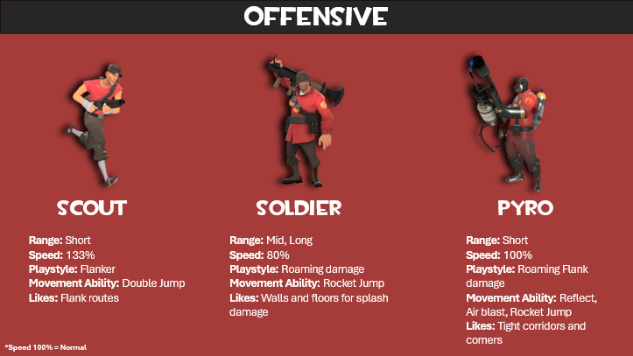

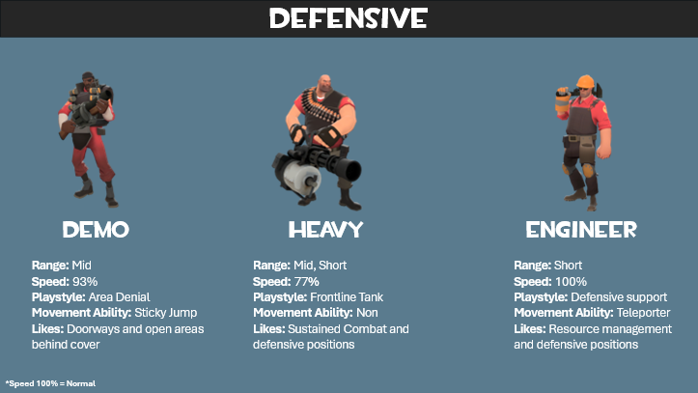
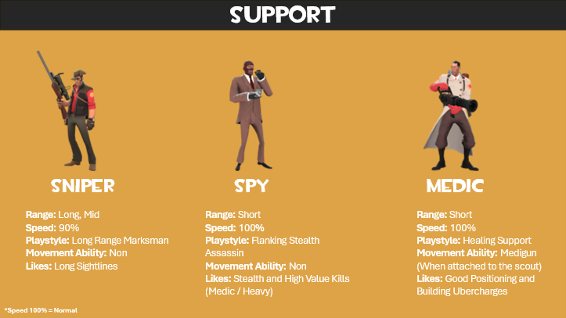

It’s important to understand that each class is designed with a specific gameplay goal in mind. Understanding how to incorporate this into the design of the map will validate the pick of any class and create a solid foundation of balance.
Scout: Fast moving, can double jump, wants to harass enemy backline (medic and other support classes)
Design Implementation: Design Vertical elements and flanking routes.
Soldier: Deal damage, control areas and can rocket jump
Design Implementation: Design areas that can be accessed easily by rocket jumping that give him the ability to hold down an area with explosive damage.
Pyro: Effective in close quarters, wants to ambush low health enemies (Snipers and Medics) and controls chokepoints.
Design Implementation: Create ambush and flanking opportunities to get on top of lower health enemies
Demo: Deal area damage, set up sticky traps and control areas.
Design Implementation: Include choke points to get to the point such as doorways or corridors and enable him to engage from a distance.
Heavy: Tank damage and return it with his minigun, protect teammates (especially Medics)
Design Implementation: Create strategic positions for him to act as the frontline tank while dealing sustained fire to enemies effectively.
Engineer: Build and maintain structures to support the team, mix offensive and defensive building placements.
Design Implementation: Desing areas for engineers to set up their buildings without being harassed, make sure there is metal nearby for the engineers to use.
Sniper: Long sightlines from a defensive position, eliminate important threats from a distance
Design Implementation: Create high ground that can be accessed easily that give sightlines to engage targets.
Spy: Infiltrate enemy team and eliminate key targets
Design Implementation: Create flanking routes and dead spots for them to wait in until the time is right to attack, also give them a route out of danger if they fail to kill anyone.
Medic: Heal teammates to provide support, position well, focus high priority classes first such as Heavy and soldier
Design Implementation: Provide cover for while healing so they don’t have to expose themselves to danger all the time, allowing them to build up Uber charges.

Multi levelled Map design
KOTH_Quarry is designed with a multi-leveled structure rather than the traditional three-lane format. Doing it this way offers a unique opportunity to create an engaging and dynamic gameplay experience, that can lead to a higher variety of player interaction along with more strategic ways to approach capturing the point, it also complements the vertical mobility of some classes in the game and means that fighting can take place more frequently from different angles and positions on the map.
The specific design of KOTH_Quarry uses the multi-level structure to keep players funneled towards the point from every floor, the floors act as tactical advantages, ambush opportunities, strategic routes, and cover, the floors seamlessly connect around the point making transfers between floors quick and strait forward.

Here are the final designs of the map

Upper Level
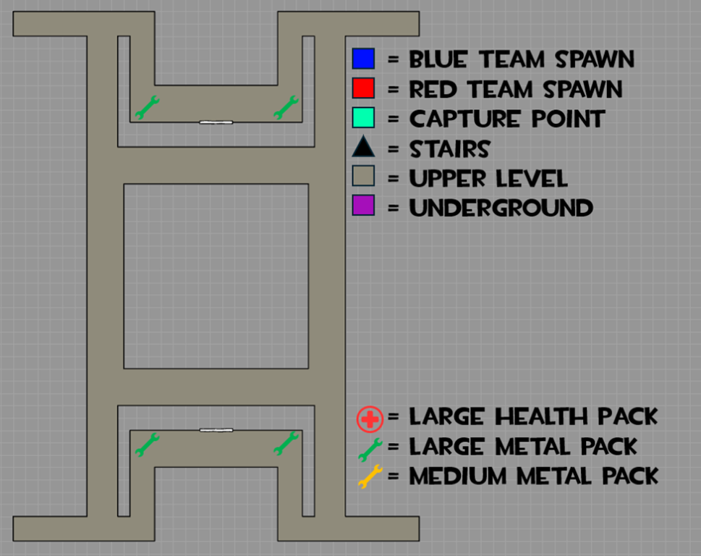

Ground Floor
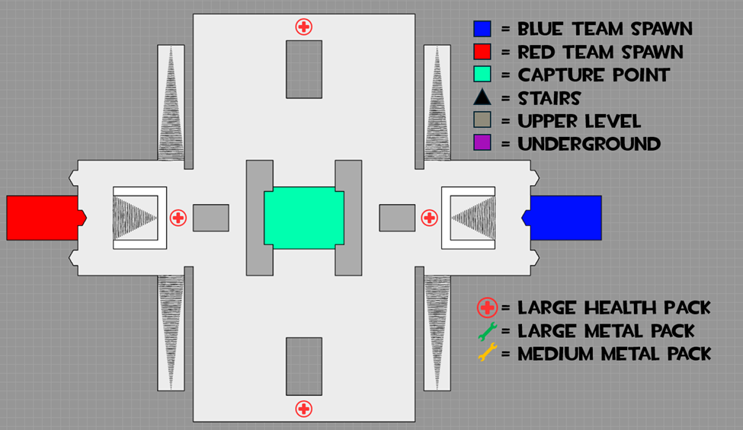
Underground
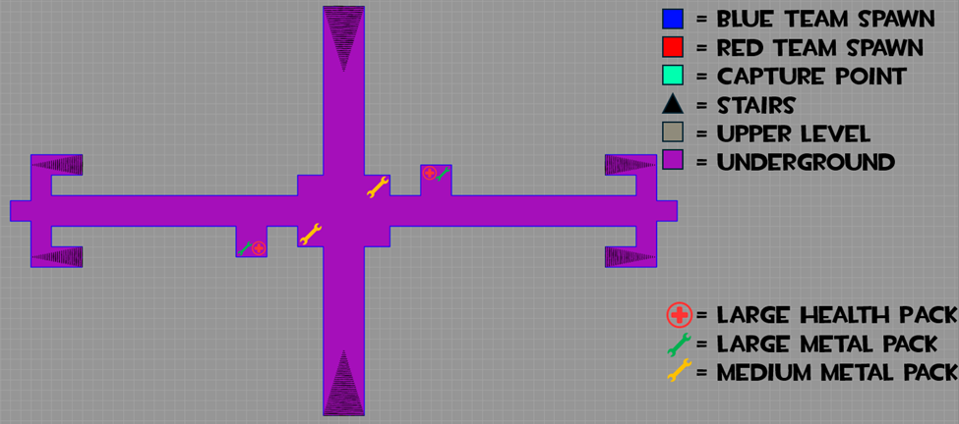

Below is a breakdown of each area, who is strong and who is weak, why it is like this and how it affects gameplay.

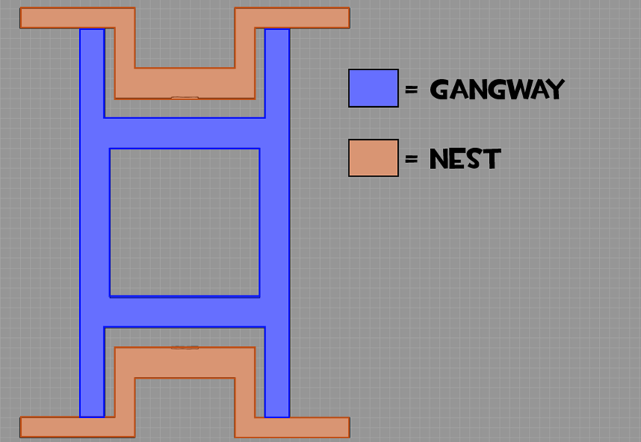
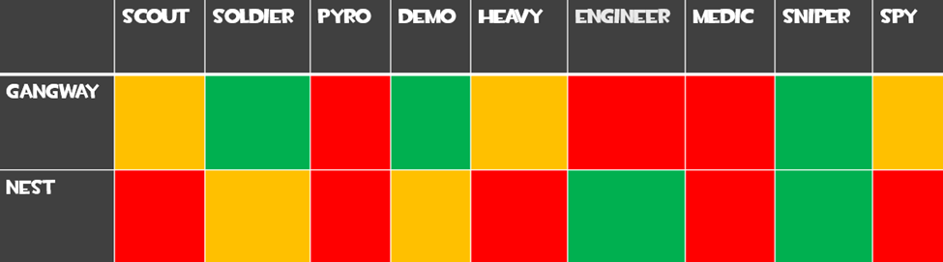Gangway
Gangway is a very exposed area of the map but in turn provides the most broken vantage points on the map. Giving clear angles strait onto the capture point classes like demo man and soldier can use this to spam the control point with their area-based damage.

Nest
Nest is an amazing spot for engineers and snipers. It gives good sightlines of the upper level for the sniper and for the engineer it acts as a haven to set up their buildings in since there are 2 medium metal packs on either side of the room.

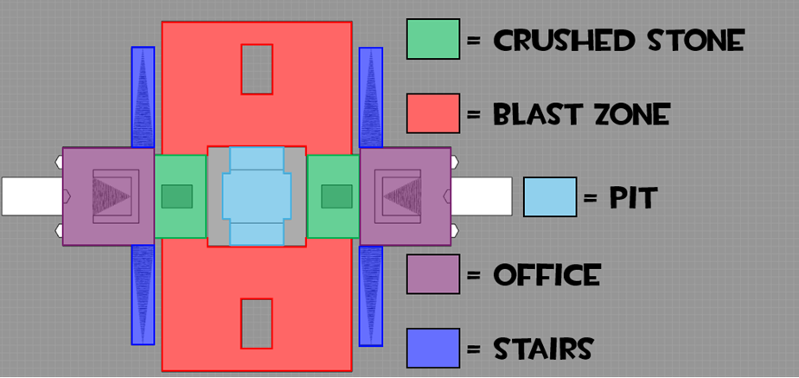
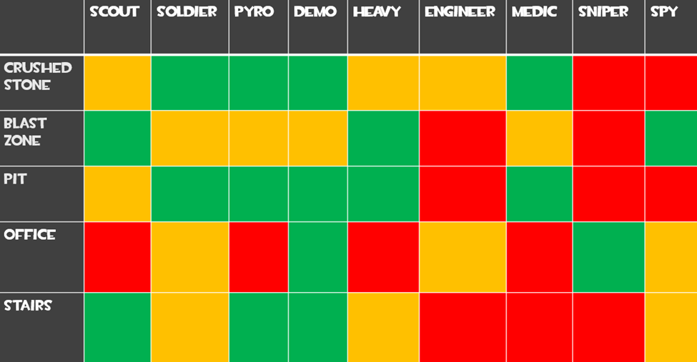

Crushed Stone
Crushed Stone is designed as the area where you either run to after taking damage or an area to fight enemies and get a good angle on them.
Classes like pyro do well here since it’s a close quarters environment very close to the point and your teams spawn so he is able to hold the corner very well.
A class that doesn’t do very well here is Sniper, sniper doesn’t want to be near the action and Crushed Stone is about as close to the action as you can get, it is also a very high traffic area with minimal cover for the sniper to hold since enemies can come from both sides and kill sniper easily.
Blast zone
Blast zone is the biggest area on the map and is where most of the action happens, it’s close to spawn and is the only way to get onto the point without going in the air and over the wall.
A class that does well here is the Heavy, the range at which you engage in is perfect for heavy, he can dip into the underground area from here to gain cover and peak over and shoot making him a formidable opponent that will need to be delt with.
A class that suffers in this area is the Engineer Blast zone is a very high traffic area meaning he never has time to set up his turrets and other buildings, and if he does manage this, they are destroyed very quickly due to the lack of cover and high damage pumped into this area.
Pit
Pit is the capture point on this map, it has high walls to provide cover facing the spawn point, this provides cover from snipers and other hit scan damage. Arching projectiles like demo man’s pipes can be blind fired over the walls from safety and the close quarters environment makes classes like scout viable as high damage dealers on the point quickly running in and out keeping up the pressure.
Office
Office is the ramp outside the main spawn door; it’s a large ramp that gives cover and a more offensive position for snipers and heavies to rain down bullets onto to map.
A class that never wants to be here is the Pyro, their short range and slow mobility means that being in this area only leads to them being exposed and more importantly out of the fight, the only reason for pyro to be here is when they run out of spawn and can spy check as this is a popular spot for spy’s to be waiting for a kill.
Stairs
This is an area that doesn’t see much combat but is used more as a transitional area to the upper level. While being quiet it does see some action if you are chasing someone down or getting chased yourself, in this situation classes like pyro and demo excel since you are in a small narrow corridor, pyro is able to utilize his flamethrower and demo man can set up very deadly sticky traps at the base of the stairs.

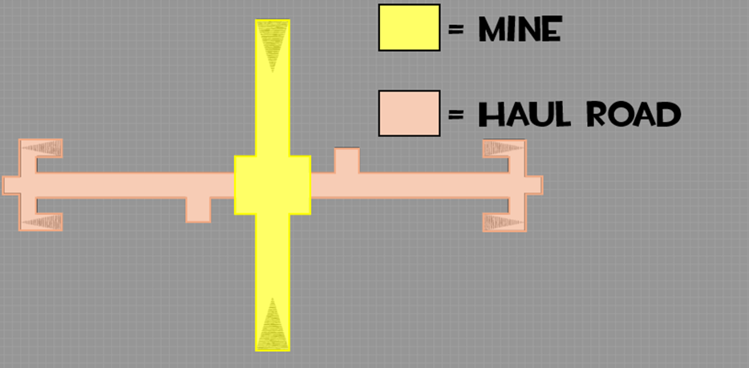
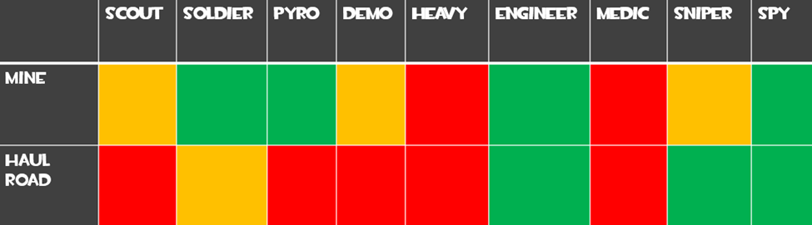
Mine
This area is the most traversed out of the 2 underground segments, this is due to the entrance and exits being in Blast Zone, it is also the most direct way to the center of the underground which has metal and health packs to pick up, it is also a great area to go if you need to get out of danger quickly and slip away alive.
Classes like the Engineer are great here as it’s quiet enough to set up their building and you will always find a low hp enemy walking through into your turret. Holding this area is very powerful and will help your team push and hold the point easier.
Medic sufferers here since there is no cover to use as he is heavily bound to other classes, if he is alone here, he is very vulnerable.

Haul Road
This area is the longest on the map and is a great way to get to the point without fighting or encountering players. The long corridor makes it a risky route but most of the time if there isn’t a sniper watching down the hallway it is a great way to go unnoticed.
Snipers are very strong here since they have the best and longest sightline on the map with incredible safety being so close to the spawn meaning snipers that are damaged can quickly go back to spawn to either get more ammo or health.
Low mobility classes Heavy and pyro terrible in this area since the length of the corridor leaves them exposed for too long meaning its easy pickings for a sniper at the other end of the corridor.

Following another playtest I got some really good feedback, people spoke about the top still being too powerful, the point being too open and the underground not being used. To respond to this feedback, I made many changes to the map.

For the point I walled it off facing the spawn, I did this to funnel players to Blast Zone making full use of the space available and to also add cover from long range attacks such as sniper shots and solder rockets, not to attack the point you must push more aggressively into open space.

For the upper level I completely removed the middle part, this opens the top drastically and completely changes how you approach this area, now going up there you have a much higher chance of being sniped and killed, but due to the fact that the point is now walled in it creates a crucible of damage making area damage classes like Solder, Demo and Pyro very strong but at the cost of cover and protection.

I moved the entrance/exit to the underground into the middle of Blast Zone, this increases the frequency of people using it to get to the underground along with making it more visible and a viable option as it’s the only cover in Blast Zone so if you’re in a pinch you can easily disengage quickly and get health and ammo.

I widened the ramp outside spawn to stop people clumping together and getting killed from people above, it also gives more angles to peak out from making sniper battles more interesting and longer. With the ramps being wider it also blocks sightlines directly into the main spawn door from Blast Zone making it harder to spawn camp from a distance.
And lastly, I made some smaller changes to the size of the rocks in the middle, and the walls around Blast Zone. I narrowed the rocks around the capture point and made the walls of the Blast Zone extrude out more making the sightline angle sharper meaning you must come in closer to view in. I did this to stop people running out of spawn and having direct sightlines into Blast Zone. It also helps with area denial from area damage weapons making holding space a bit easier.

This is the final iteration of my map.

